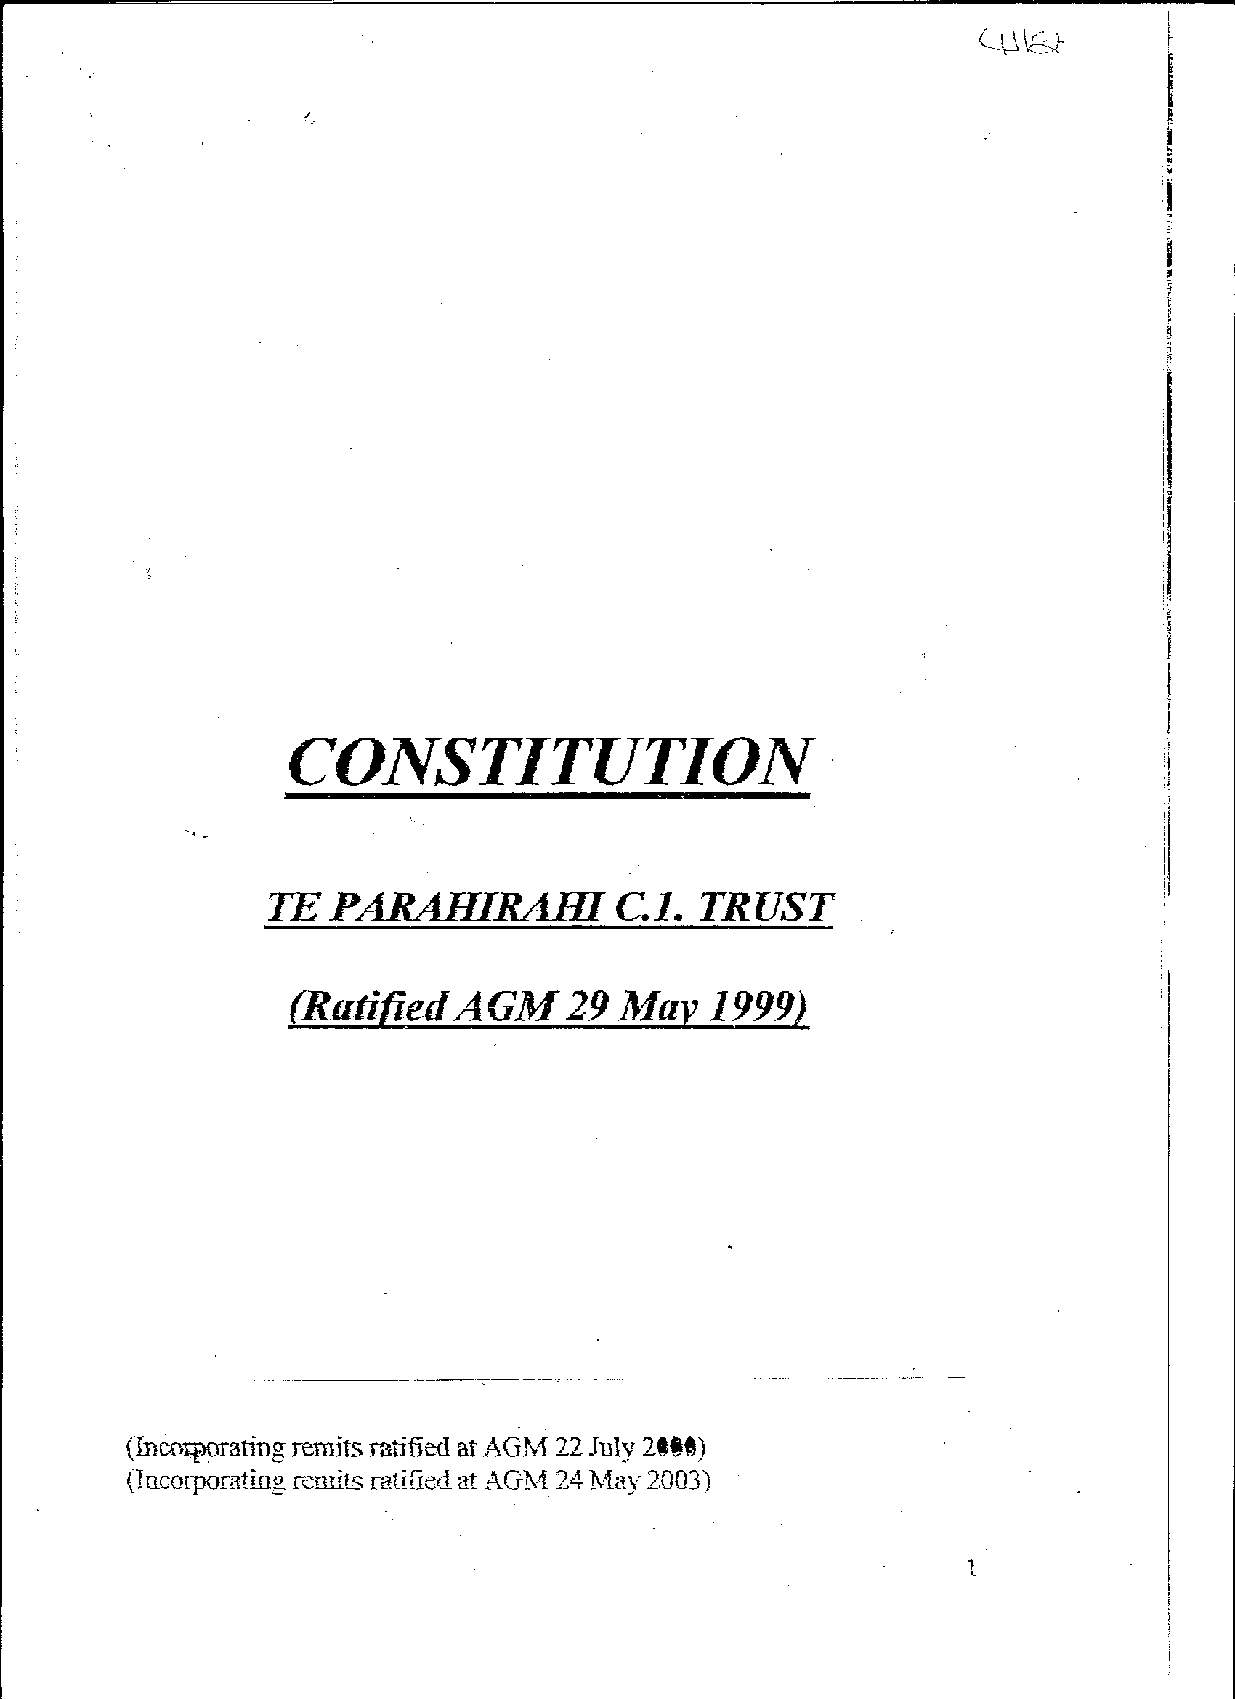
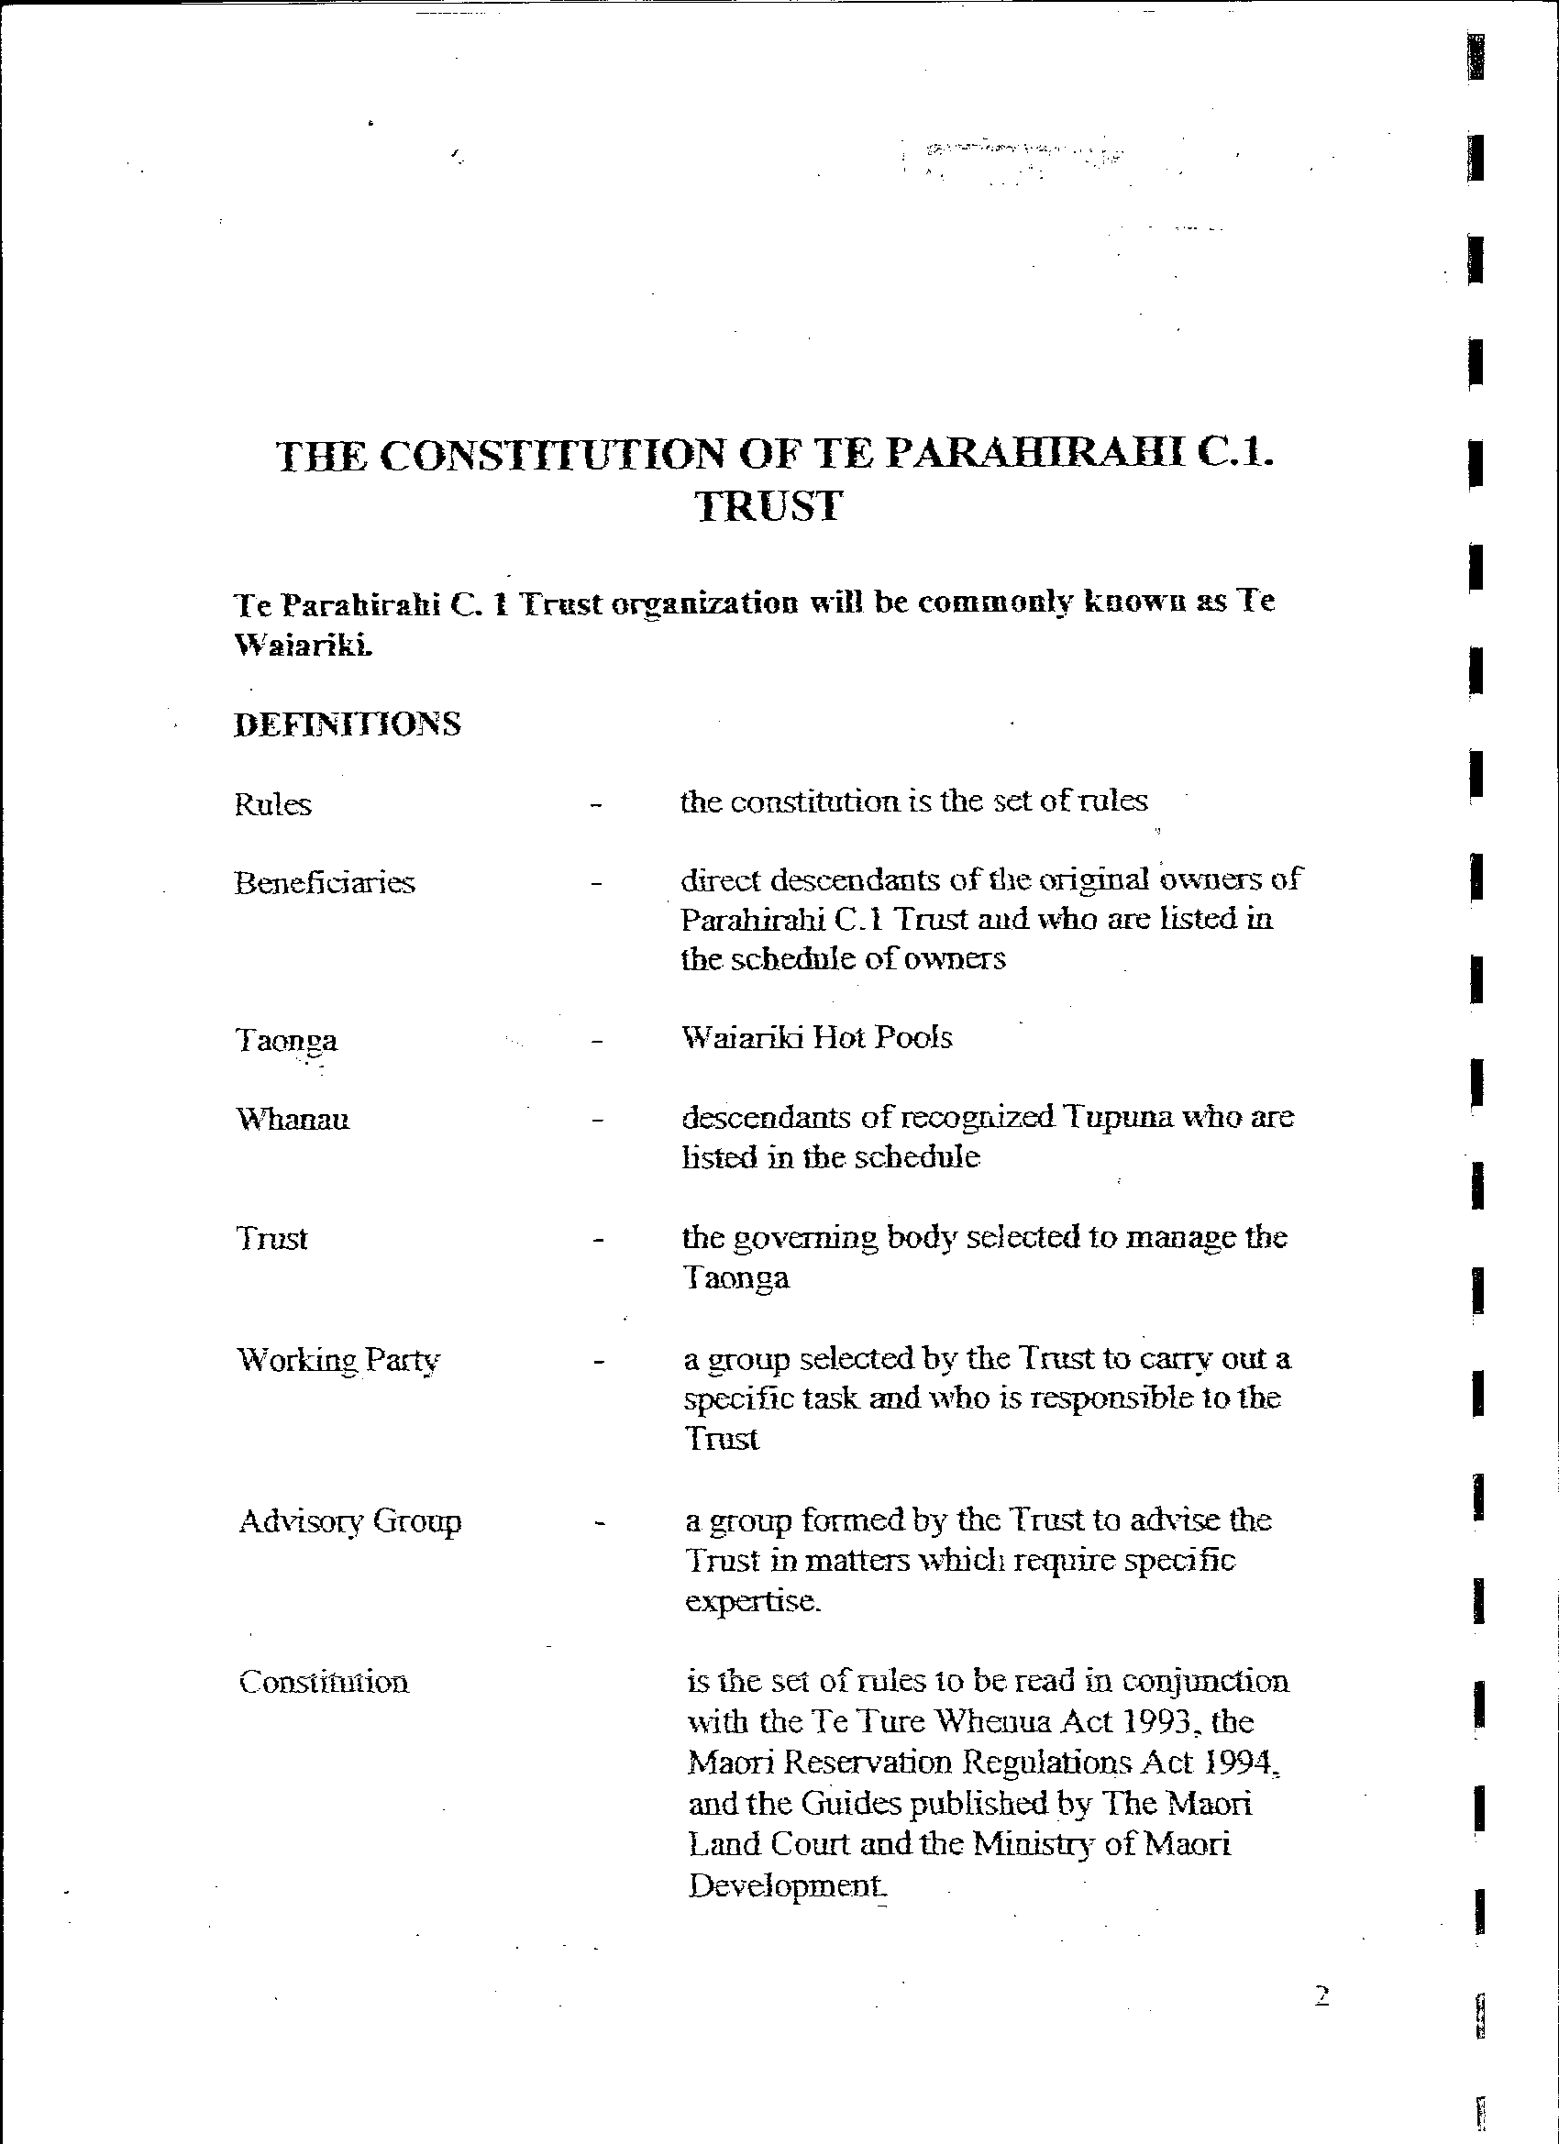
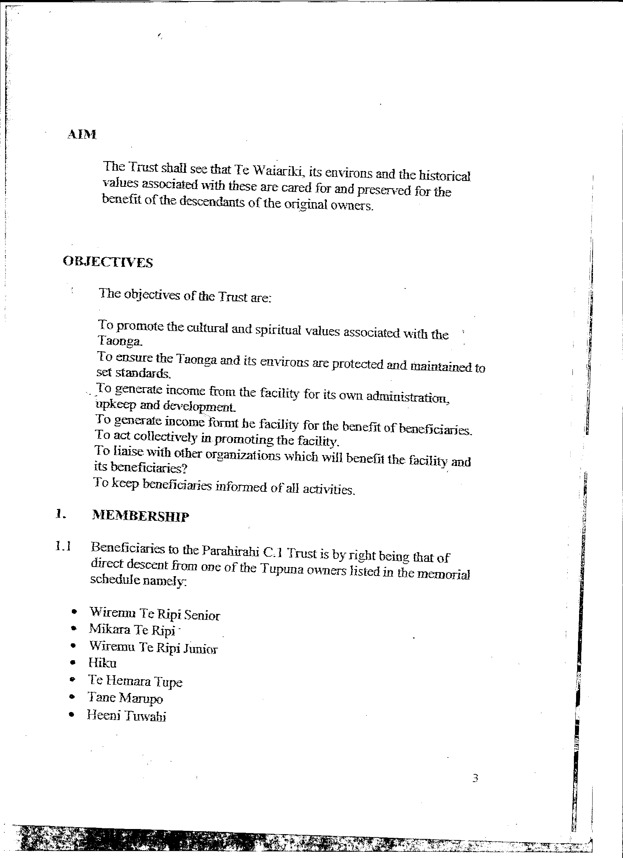
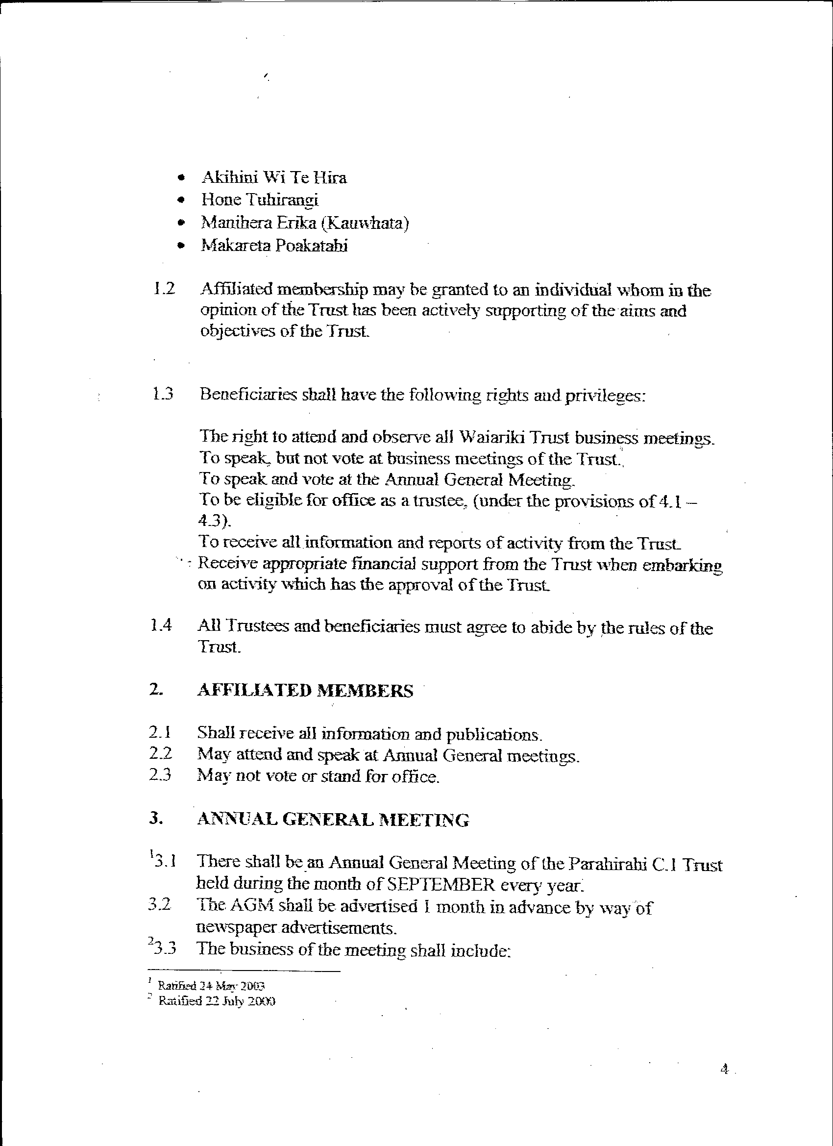
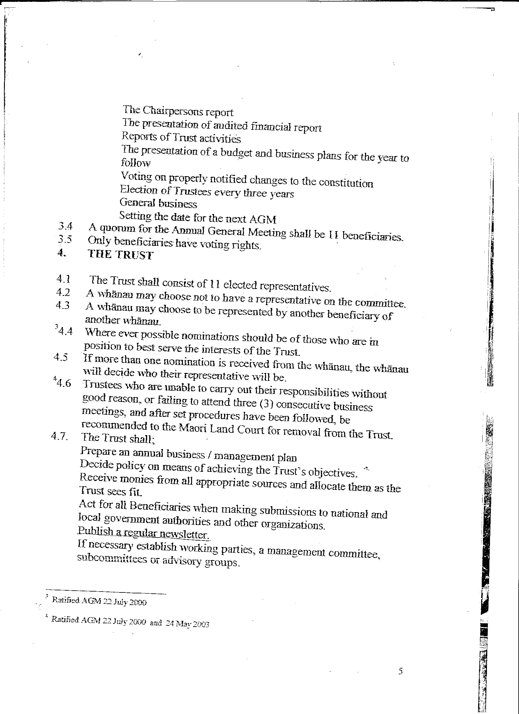
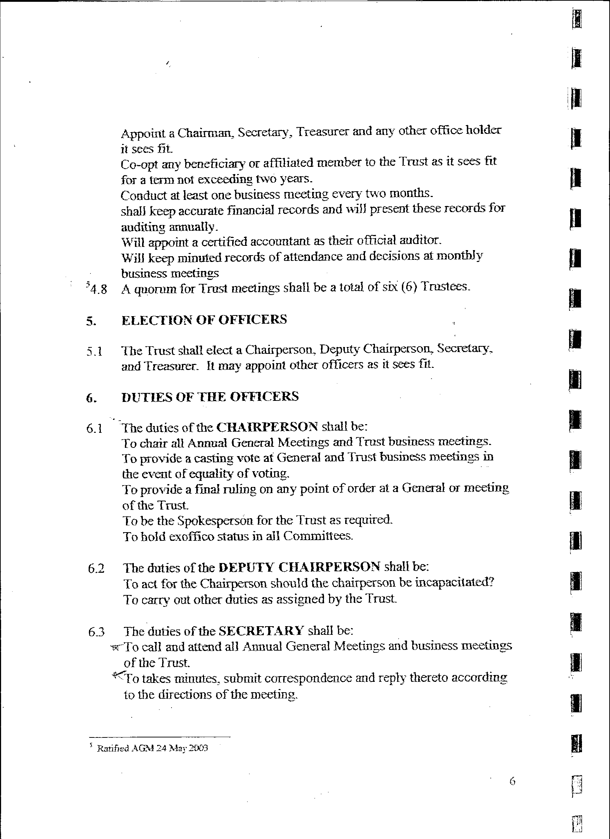
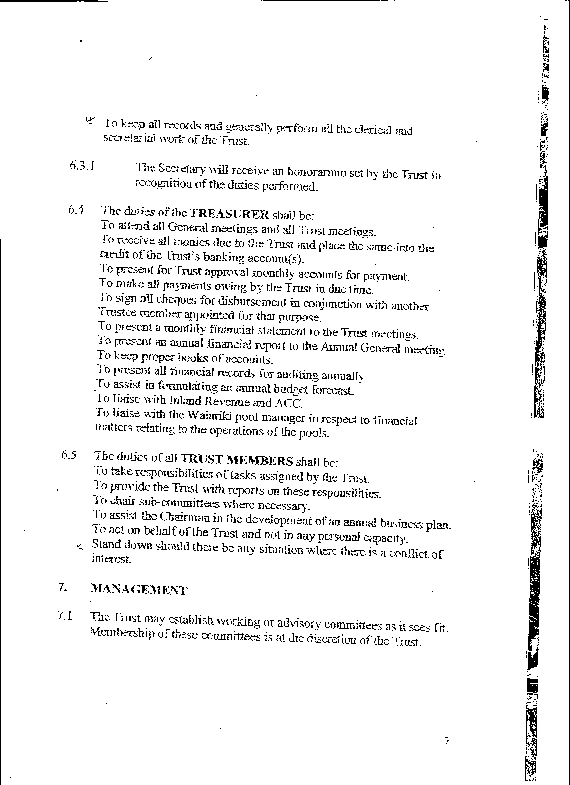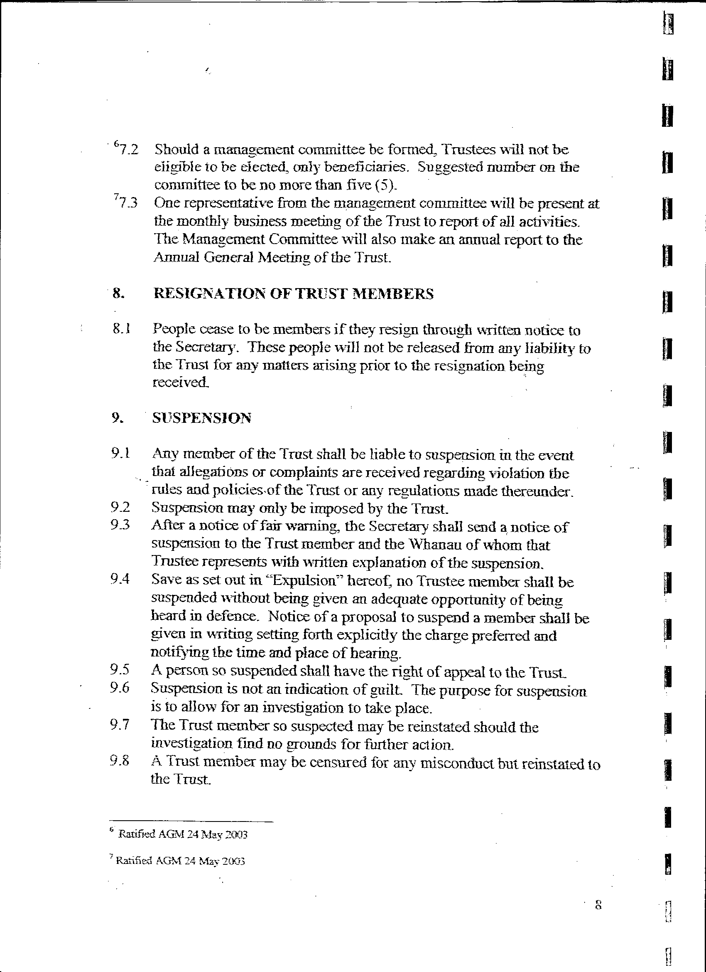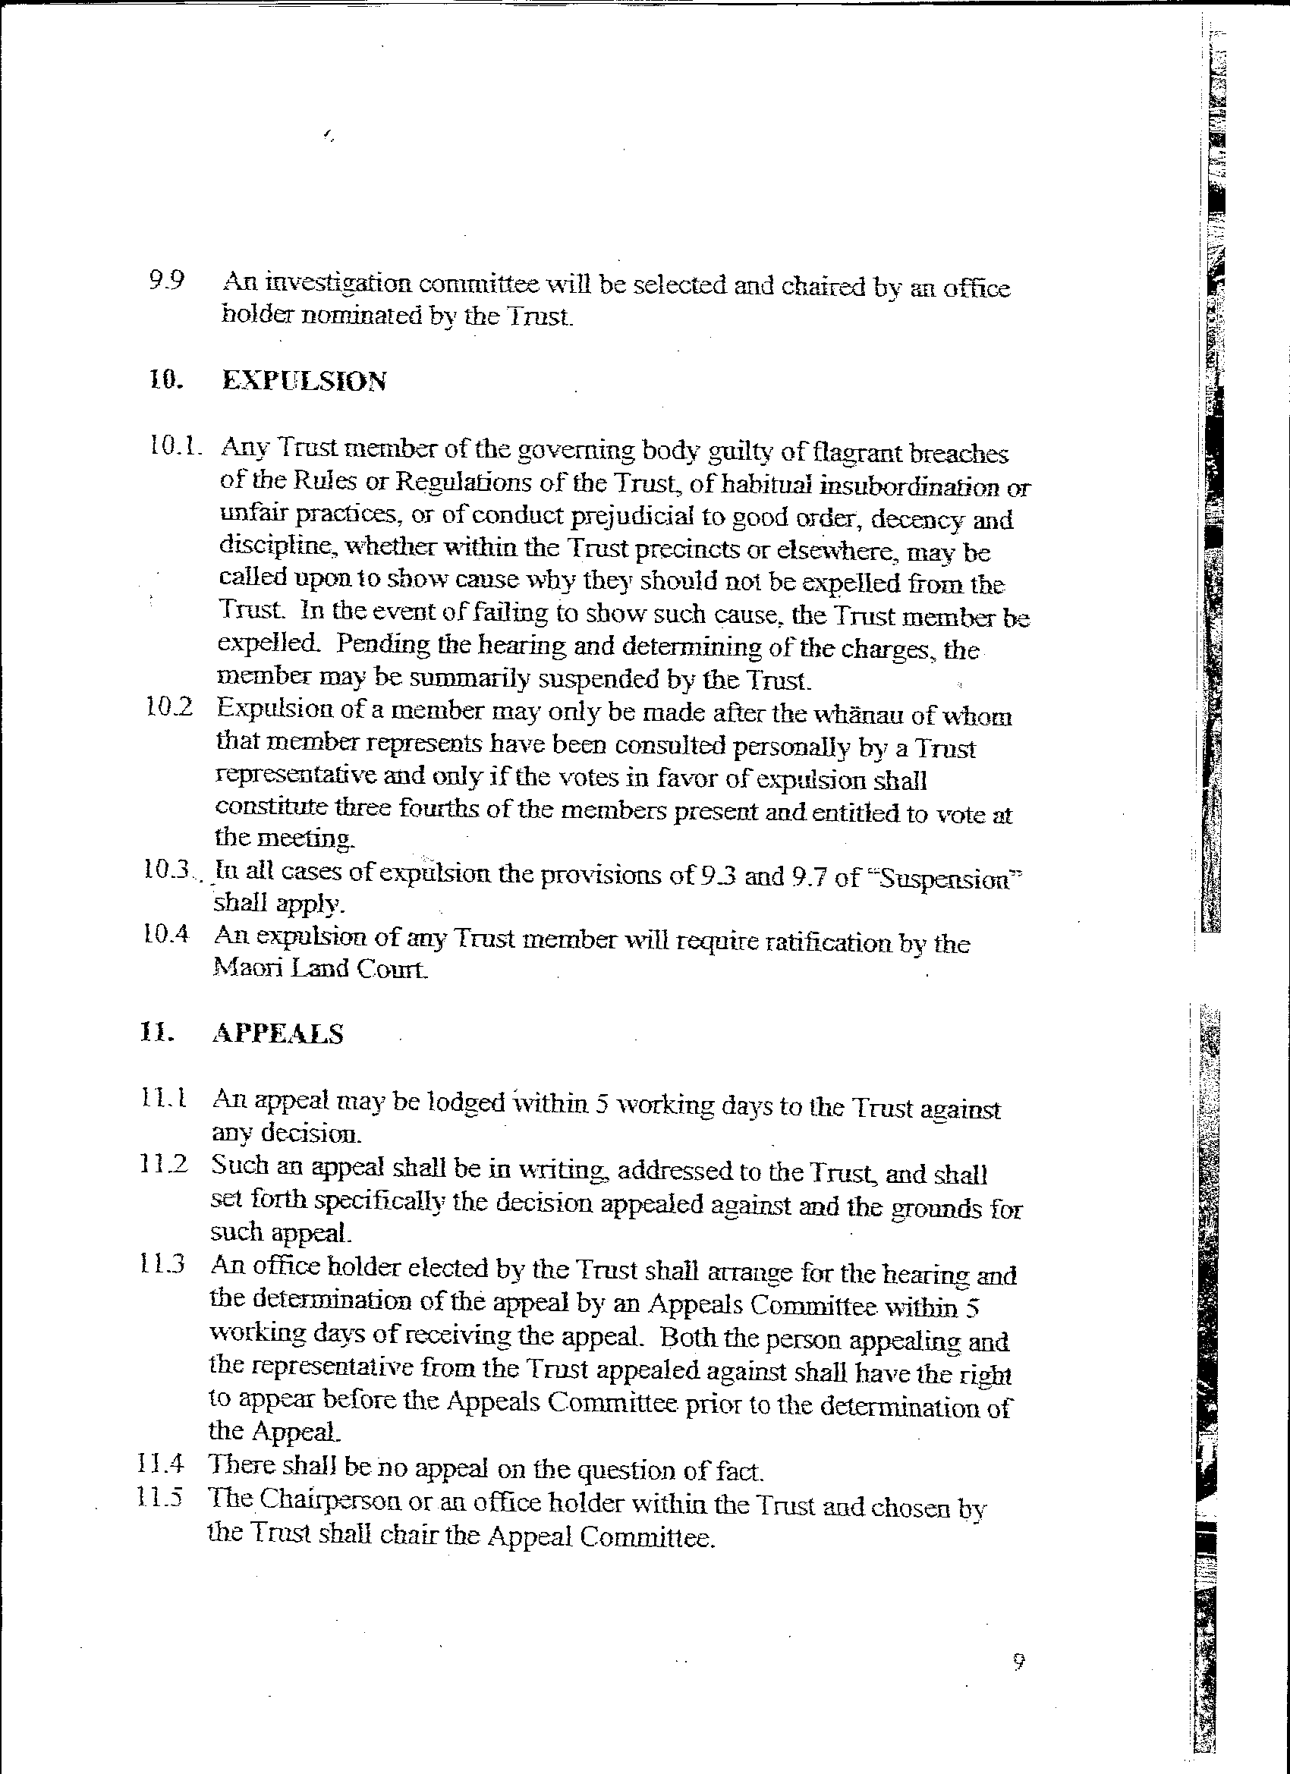
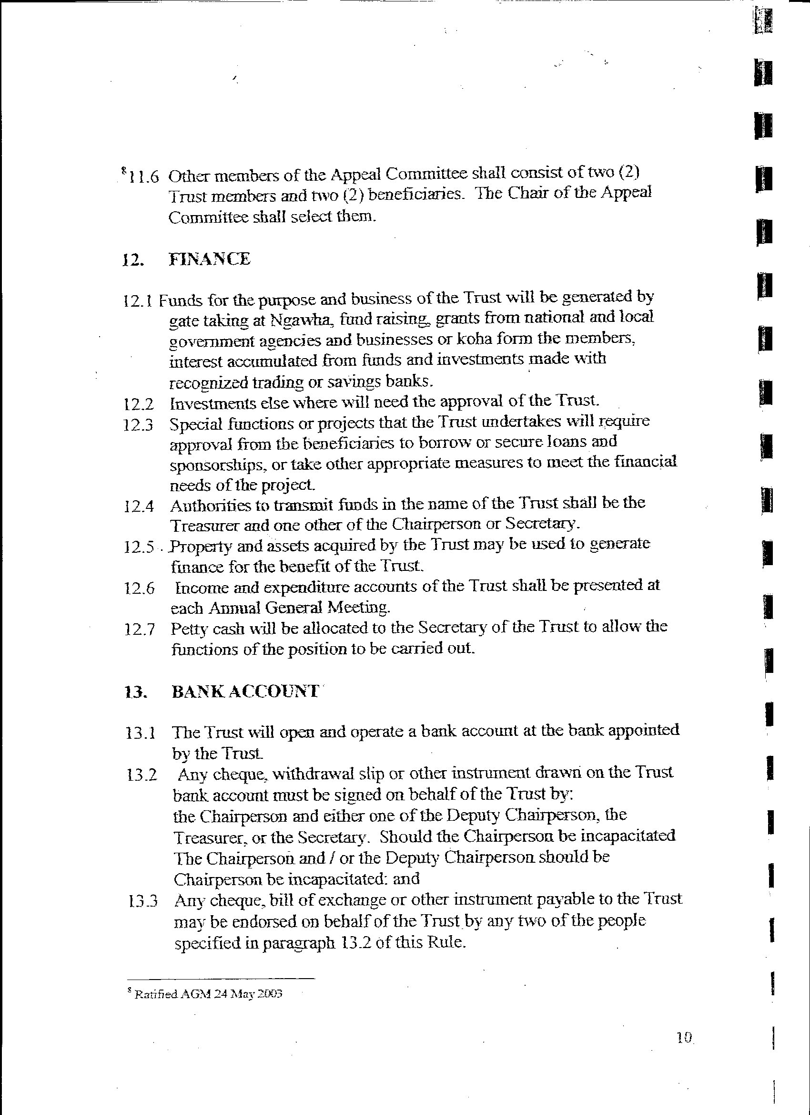

13.4 All funds of the Trust must be lodged with the Trust's bank.

14. USE OF FUNDS

14.1 The income and any property of the Trust shall be applied solely towards the promotion of its objectives and no part thereof paid or transferred directly or indirectly by way of profits, dividends, bonus or otherwise to the members of the Trust or any one of them, and except as payment made in good faith of remuneration to any employee or as an award by the Trust. No Trust member shall in any way receive any pecuniary gain from the property or activities of the Trust.

14.2 All monies received by or on behalf of the Trust shall unless the Trust otherwise directs, be forthwith paid to the credit of the Trust's account with its banker, and all payments made on behalf of or by the Trust (except petty cash payments) shall be made by cheque drawn on that account and signed by such persons as specified in paragraph 13.2.

14.3 All monies surplus to trading requirements shall be invested on behalf of the Trust and all interest received shall be returned to and used for the objectives of the Trust.

15 COMMON SEAL

15.1 The custodian of the common seal of the Association will be the Trust's secretary

15.2 The common seal of the Trust shall be used on material issued and validated only by formal Trust validation.

16 PROPERTY

16.1 A register of capital assets will by kept with the secretary, updated as needed and available at AGM for perusal. Property and assets may be used to generate funds for the use of by Trust.

17 ALTERATION OF RULES

17.1 The constitution and rules may be altered from time to time only when a motion of the proposed alteration has been received in writing, by the secretary of Trust 2 weeks prior to the next AGM, and passed by a 75% majority vote of those present at the meeting.

